M2015 Linux driver release note
Xorg driver
Version | Release Date | Revision | Note
0.0.1 | 2014/12/29 | 7981 | - Add M2015 chip ID support  - Rename driver name from rdc_drv.so to rdcm15_drv.so

- How to use HDMI under screen setting
Step1.
Use editor tool to open xorg.conf file in /etc/X11 folder.
Step2.
Edit Section “Device” item in xorg.conf file
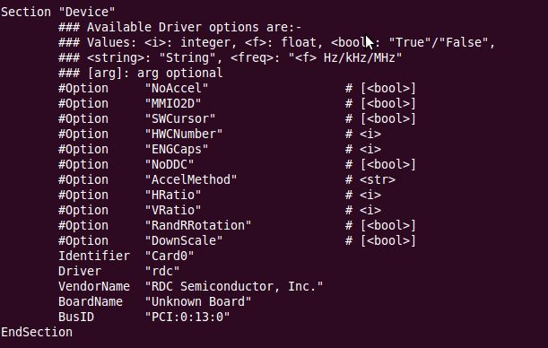

Step3.
Add two options “HRatio” and “VRatio” in Section Device as the following.
The “HRation” and “VRatio” values must be less than or equal to “100”.
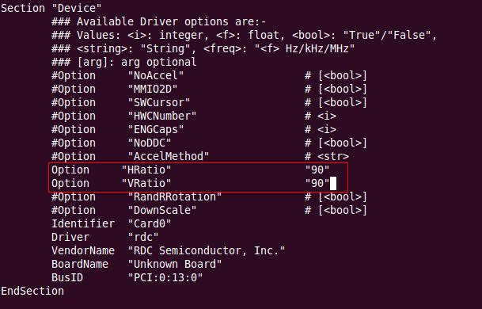

Step4.
Logout X-window and restart X-window to reload xorg.config.

- Limited mode size fit HDMI 720P timing.
Step 1.
Use editor tool to open xorg.conf file in /etc/X11 folder.

Step 2.
Add Modes 1280x 720 option in xorg.conf as following:
Section "Screen"
Identifier "RDC Screen"
Monitor "RDC Monitor"
Device "RDC VGA"
DefaultDepth 24
SubSection "Display"
Depth 24
Modes "1280x720"
EndSubSection
EndSection

